TABLE OF CONTENTS

EXECUTIVE SUMMARY 1
LORD BADEN POWEL AND PAXTU COTTAGE 3
TREETOPS LODGE 5
ITALIAN MEMORIAL CHURCH 6
DEDAN KIMATHI KAHIGA-INI SITE AND MAU MAU CAVES 10
Dedan Kĩmathi Kahiga-ini site 10
MAUMAU CAVES 10
1. Narumoro Caves 11
2. Kieni gia Kabia (MauMau Caves) 11
3. Ngaini Caves (MauMau Caves) 12
4. Ndomboche Mau Mau Site 12
Administrative location. 12
5. Mau Mau Trench – Mathira Section 14
Administrative Location 14
6. Chinga Dam 15
7. Kariba Caves 16
Administrative location 17
FLAG SITE 20
Administrative Location 21
REFERENCES 22

EXECUTIVE SUMMARY

The County has a strong historical heritage and is home to the Mau Mau War Hero General Dedan Kimathi. Most of the Mau Mau activities were centered in Nyeri County hence there are many caves which were used as homes for the freedom fighters. The proposal indicate sites that can be considered by the UNESCO to be world heritage sites. Some of these sites include
- Lord Baden Powell Paxtu Cottages inside the Outspan Hotel.
- The Treetops lodge.
- Italian Memorial Church – Mathari.
- Dedan Kimathi Trench-Kahiga-ini and the Mau Mau Caves.
- Mau Mau Graves
- Blessed Irene Stefani Nyaatha Shrine/Museum at Gikondi Parish (under construction).
- Flag site.
- Chinga Dam
- Aberdare National park
- Wangari Maathai Monument
They also indicate their location, history and the criteria according to the UNESCO guidelines.

LORD BADEN POWEL AND PAXTU COTTAGE

The Lord Baden Powel grave is the third most visited grave in the whole world. This puts Kenya and particularly Nyeri County squarely on Kenya tourism map. The Baden Powell grave is therefore a marketing gem for Nyeri County.

The historical garden is about 2-acre piece of land with almost a half of it being occupied by St. Peters cemetery where among those buried is the founder of scouting movement Lord Robert Baden Powell and the ashes of his wife Olive Baden Powell. It is among other graves of Europeans who may have been faithfuls of the Anglican Church. The grave is the most prominent and noticeable feature occupying a central point in the cemetery.

The graveyard is a national monument and a very important site for the Boys Scouts and Girls Guide Association and hosts the Founder’s Day annually. It was gazetted on 9th March 2001 Gazette Notice Number 1427. The path to the gravesite has stones with scouts and Girl Guide values written on them and also the promises of both groups.

Administrative Location

Sub-location: Rware
Location: Mũkaro
Sub County: Nyeri Central
County: Nyeri
Coordinates: S00°25’08.6” E036°57’01.0”
Elevation: 1814meters

Boy scouts and girl guides worldwide visit the museum annually and particularly on 22nd February when they celebrate the founder’s day. The first Founder’s Day was commemorated in 1928. The following are major scouting activities, nationally and internationally: -
- Jamboree – this a large international gathering of Scouts, held generally every four years. The 24th World Jamboree is to be held in North America in 2019.
- Scouts moot – The World Scout Moot is an event for senior branches (traditionally called Rovers) and other young adult members. Moots provide an opportunity for young adults in the scouting movement to meet with the objective of improving their international understanding as citizens of the world. Moots are held every four years and are organized by the World Organization of the Scout Movement (WOSM)
- Roveree - is a congregation of scouts aged 18-26 years (the rovers) also known as assistant scout leaders. They are organized into crews of 10-32 scouts with one of them being in-charge of the crew. Inter Patrol Competition (IPC). These are organized Regionally, the 2018 IPC was held in Burundi
- Camps (these are purposed for training & Leisure)
Africa Scouts Day. This is a continental activity and in 2018, it was organized to be held in Zimbabwe.

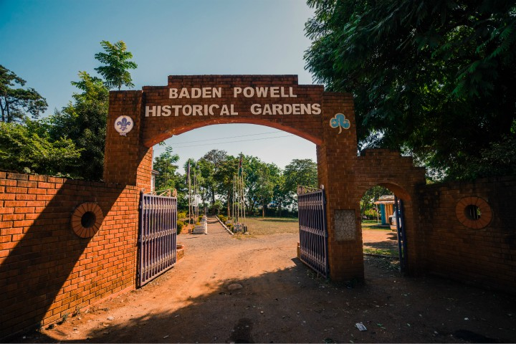
Baden Powell Historical Garden
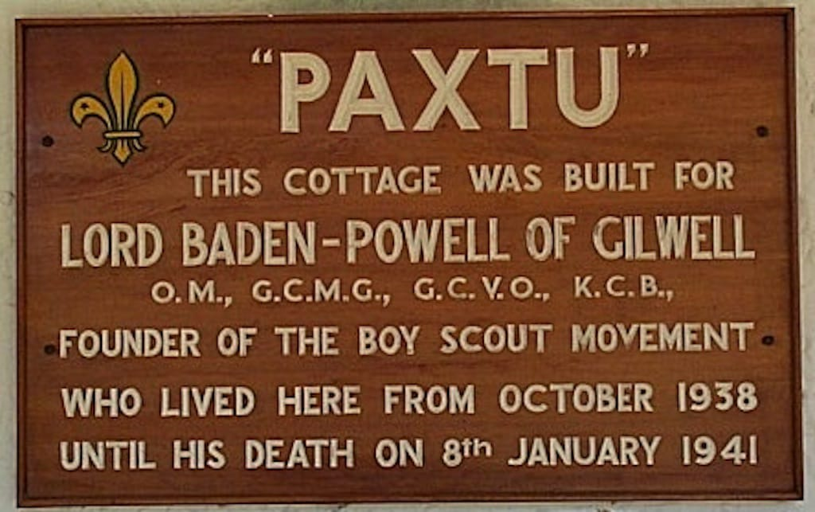
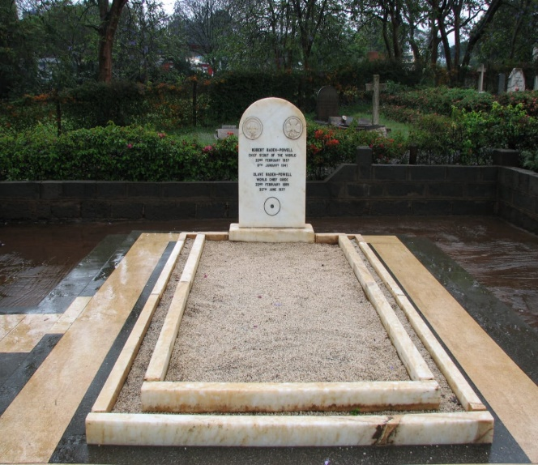
Baden Powell Grave

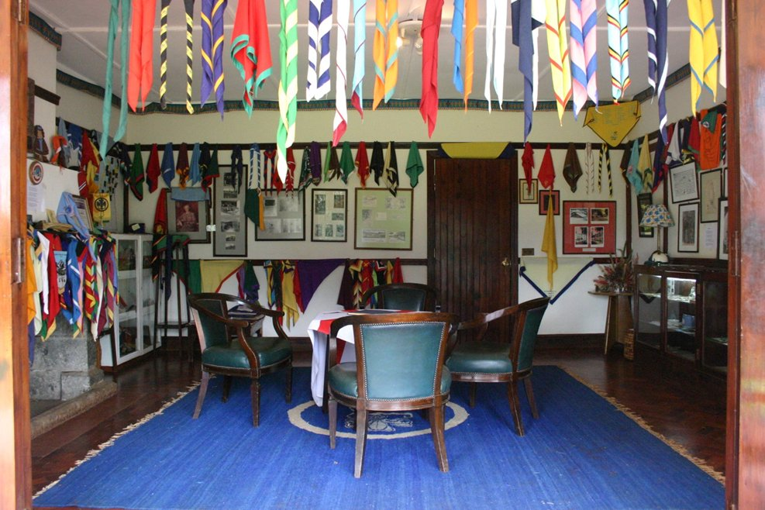
Paxtu Museum

This site can be nominated as a world heritage site under Criteria 6 which states be directly or tangibly associated with events or living traditions, ideas, or beliefs, with artistic and literary works of outstanding universal significance. The site is directly associated with events (Boy scouts and girl guides worldwide visit the museum annually and particularly on 22nd February when they celebrate the founder’s day).

TREETOPS LODGE

Treetops hotel was designed and constructed by Sherbrook walker who had visited Kenya for the first time in 1918 when he was a soldier in the First World War fighting in Ethiopia and after leaving Ethiopia he decided to settle in Nyeri. During his stay he noted that Aberdares had turned into a hunter’s paradise driving some animals such as rhinos to near extinction. This challenge motivated him to design tree tops hotel at a spot where animals congregated in large numbers to lick salt and drink water. His idea was that, rather than shoot animals with guns, visitors would have a chance to shoot them with their cameras.

Administrative location

Sub-Location:
Location:
Sub-county: Kieni West
County: Nyeri
Coordinates: 00⁰21’30’’ South, 36⁰54’48’’ East, 24 ½ miles south of the equator
Elevation: 1954m/ 6450 ft above sea level,
The original structure was a two-roomed tree house first opened in 1932. Today, it is designed with observational lounges and ground-level photographic hides from which guest can observe the local wildlife which comes to the nearby waterholes/salt lick.
Currently it has 36 rooms including a special room no.18 known as Princess Elizabeth or the honey mooners’ room. It was originally used by Queen Victoria in 1959 while Queen Elizabeth II visited for the second time in 1983 and slept in that room. This significantly raised the profile of the room and the hotel.
Princess Elizabeth climbed on 5th February into a tree, after having what she described as her most thrilling experience only to descend the next day on 6th February as her Majesty Queen Elizabeth II after the death of her father King George VI. Her Majesty later returned to Treetops Lodge on 13th November,1982 which was 30 years later after her first visit.

This site can be nominated as a world heritage site under criteria 6 which states; be directly or tangibly associated with events or living traditions, ideas, or beliefs, with artistic and literary works of outstanding universal significance.
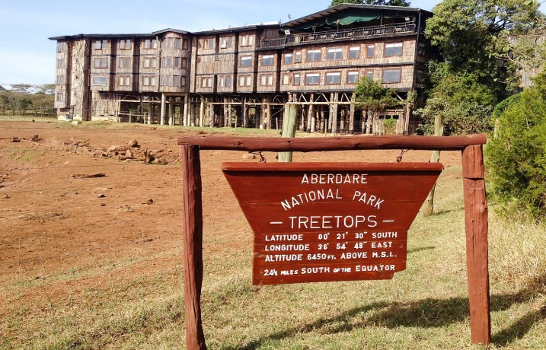
Treetops Lodge

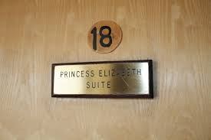

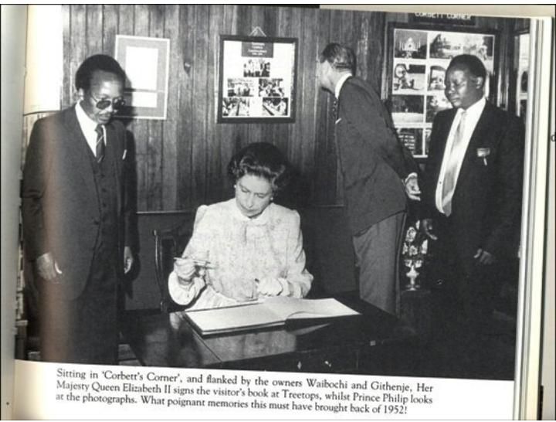
Queen Elizabeth Signing the visitor’s book at treetops lodge


Queens’s room

ITALIAN MEMORIAL CHURCH

The entire facility is set on two acres of land but the Church building and accompanying infrastructure could be occupying about ½ acre. There are two flag posts the one to the left as one approaches the entrance, hoists the Kenya flag while the one to the right hosts the Italian flag during the annual memorial mass.

The magnificent door is decorated with curving of animals, chalices, dragons and many other symbols as described in the book of revelations in the Holy Bible. Inside the Church there is a statue of Prince Amadeo, Duke of Aosta, who was the senior Italian army officer in East Africa. His tomb is strategically positioned near the altar; Amadeo was the commander of the Italian forces in East Africa, when Italy declared war on the United Kingdom and France in 1940.

Administrative Location

Sub-Location: Mathari
Location: Kamakwa
Sub-county: Nyeri Central
County: Nyeri
Coordinates: 00.41474⁰ S, 036.92439⁰ E, Elevation - 1871M
Ownership: Italian Embassy, Nairobi
Distance: 5 kilometers from Nyeri town

The facility sits on approximately 2 acres of land that was donated by the Catholic archdiocese of Nyeri.

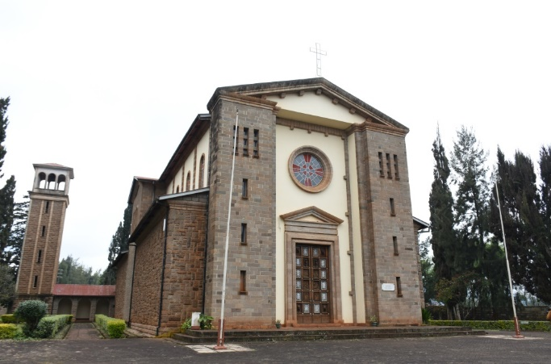
The Italian memorial church with a view of the bell tower (a latter addition)
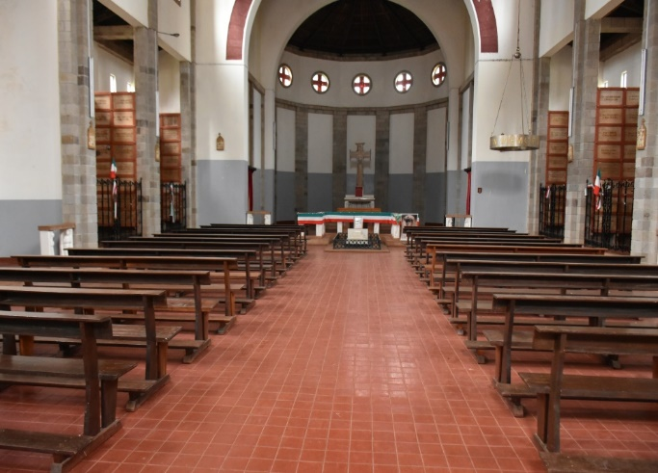
A View showing inside of the Church
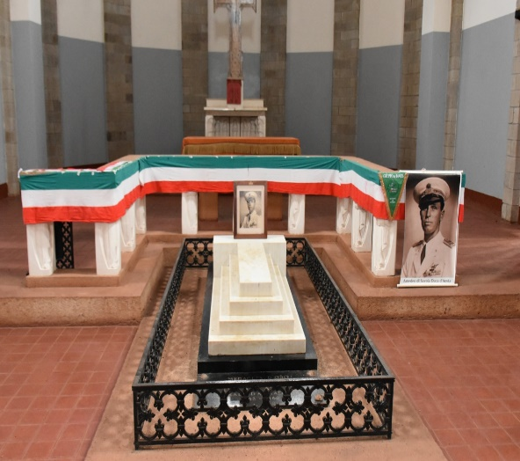
Amadeo’s tomb with the alter in the background

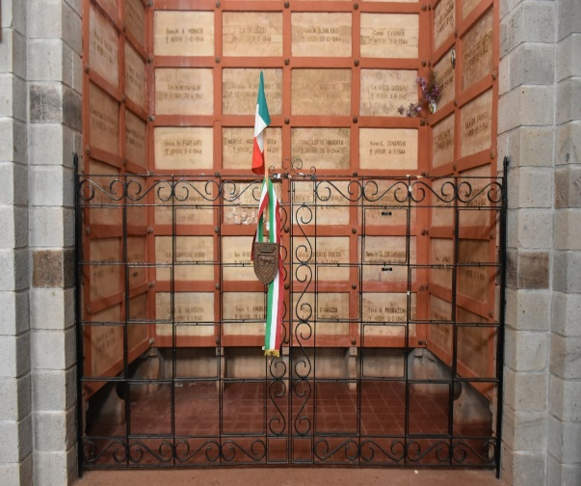
Vaults containing remains of non-Christian soldiers preserved outside the main Church

The serenity of the shrine is enhanced by a tree-lined drive and manicured lawns. It is not an ordinary church but hosts the remains of 676 Italian soldiers captured and killed during the 2nd world war.
This site can be nominated under criteria number 4 which states; be an outstanding example of a type of a building, architectural or technological ensemble or landscape which illustrates (a) significant stage(s) in human history.
This site can also be nominated under criteria 6 which states; be directly or tangibly associated with events or living traditions, ideas, or beliefs, with artistic and literary works of outstanding universal significance. The church commemorates an annual mass on Nov 4th in remembrance of the Italian soldiers.

DEDAN KIMATHI KAHIGA-INI SITE AND MAU MAU CAVES

Dedan Kimathi Kahiga-ini site

This site brings to memory the capture of Field Marshal Dedan Kĩmathi Wachiuri and later his trial. Kĩmathi together with Musa Mwariama fearlessly lead their Mau Mau troops against the British forces and their African allies (Kamatimu). The site was gazetted as national monuments on 9th March 2001 vide Gazette notice no. 1427.
The site is marked by a small monument with his photo and one of his famous quotes “it is better to die on our feet than to live on our knees for fear of colonial rule”. To the east it borders an access road contracted just next to what was the famous Mau Mau trench.
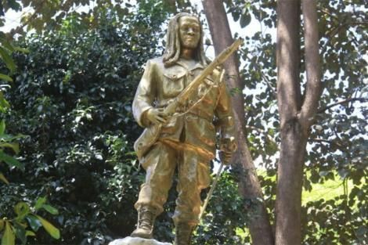
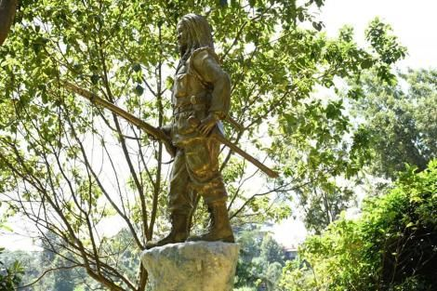
Dedan Kĩmathi Monument-Kahiga-in
This site can be nominated as a world heritage site under criteria 2 which states; exhibit an important interchange of human values, over a span of time or within a cultural area of the world, on developments in architecture or technology, monumental arts, town planning or landscape design.

MAU MAU CAVES

The County has a strong cultural heritage and is home to the Mau Mau War Hero General Dedan Kimathi. Most of the Mau Mau activities were centered in Nyeri County hence there are many caves which were used as homes for the freedom fighters. They include:

Narumoro Caves

The caves may have been used by the Gumba people who roamed this area before the Kikuyu settled here. These were hunters and gatherers, who lived in these caves as evidenced by the discovery of bones from the animals they killed for food. This particular cave was discovered by a group led by General Kariba, and since it was large enough, they decided to use it as a nursing bay for injured soldiers..
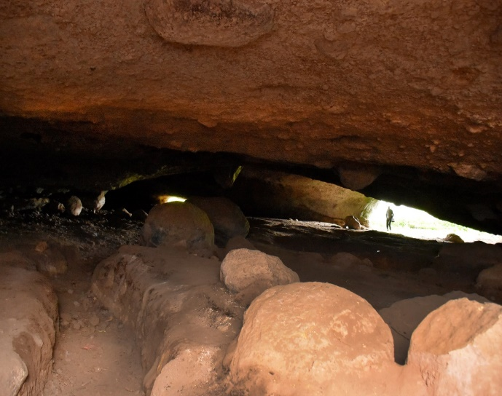
Inside the expansive cave

- Kieni gia Kabia (Mau Mau Caves)
The Kieni gia Kabia Caves at the foothills of Mt Kenya open out to a beautiful waterfall and pass-through rocks on Burguret River. Once shielded by a dense forest cover, these caves near Narumoru are well known for their historical significance. During the Emergency period between 1952 and 1960, the Mau Mau Freedom fighters used these caves for storing supplies and as a hideout from colonial forces.

Ngaini Caves (Mau Mau Caves)
These Mau Mau caves are located at the forest block of Mt.Kenya forest reserve. The forest reserve is a mixture of plantation and indigenous forests occasionally interrupted by green carpeted grass openings. The location of these caves is spectacular. Since they are mostly concealed by undergrowth and indigenous trees which include olive oak, cedar, they are easy to miss without a guide.
The Ngaini caves have a significant place in the history of Kenya, and more so the history of the struggle for independence. They were used as military bases by the Mau Mau war heroes. Besides serving as a hideout, all freedom war plans were made and executed from these caves. The cave served as a workshop for home-made riffles and other military equipment, storage for stolen ammunitions, foodstuffs and other ordinances.

Ndomboche Mau Mau Site
This site is characterized by huge boulders along River Kahuru, it is V-shaped and slippery to walk down the valley particularly during wet weather conditions. In the 1950’s it was a thick riverine forest which has been lost gradually over time. During the Mau Mau liberation war, it was used as a hide out for the Mau Mau. Women used to take food and other necessities and hide them between or under the rock boulders for the Mau Mau to collect. The cave was gazetted by the National Museums of Kenya as a national monument vides notice no 13561 dated 28th Sept 2012.

Administrative location.

Sub Location: Kahuru
Location: Iria-ini
Sub County: Mathira
County: Nyeri
Coordinates: S00.45836° and E037.16037°
Elevation: 1774meters asl
Ownership: The site is within a riparian area

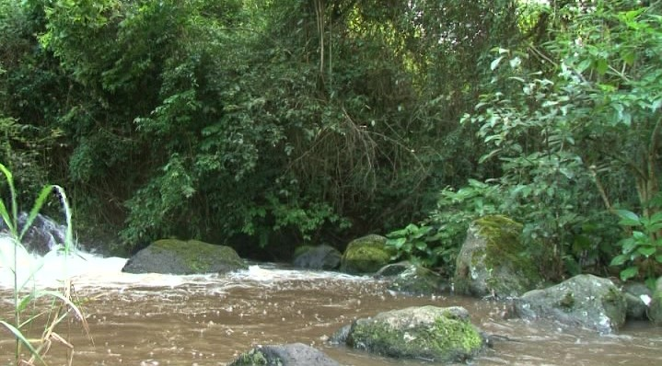
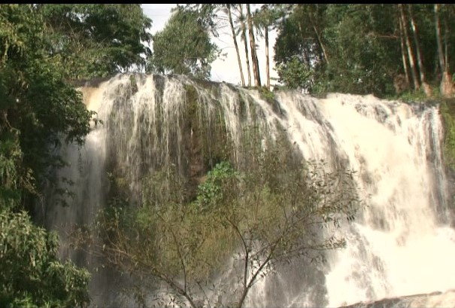
Mau Mau hide out at Ndomboche Scenic Kahuru River falls

Mau Mau Trench – Mathira Section

The Mathira trench started at Ndima-ini the boundary of Nyeri and Kirĩnyaga. The Mau Mau rebellion was a big threat to the white settlers and colonial administrators. The declaration of the state of emergency by the governor (October 20th, The Mathira people dug their part up to Sagana state lodge (Beyond this point there were many settlers), while the Kirĩnyaga people started at Ndima-ini and moved towards their boundary with Embu. The trench measured approximately ten feet deep by ten feet wide. 1952) was one major step towards suppression of the movement. The trench was later filled up with bamboo spikes (nyambo) to keep the Mau Mau fighters from crossing into the villages. However, they still managed to cross to the village to get food.
Though the trench is filled up due siltation hence reducing the depth as well as the width. The trench runs all-round the entire western and south-western parts of Mount Kenya forest. In most sections, it is insignificant as local people grow Napier grass inside. Since the trench was dug at the edge of the forest, this also turned out to be the preferred space for construction of access roads. It is imminent that if sections of the trench are not conserved, it may entirely fill up or be covered through various human activities.

Administrative Location

Sub-location: Kanjuli
Location: Muthea
Sub-county: Mathira East
County: Nyeri
Geographic coordinates: 0.38524⁰S, 037.4185⁰E
Ownership: It is on a road reserve

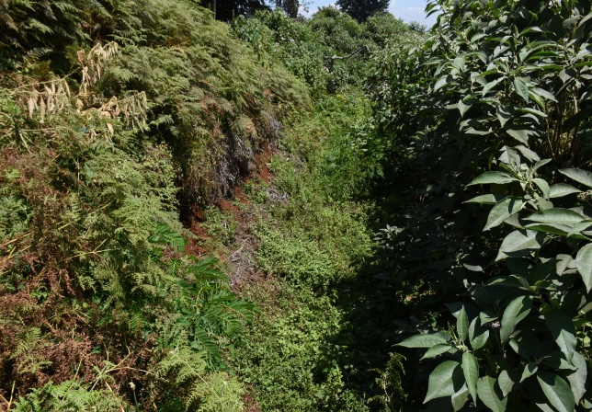
A section of the infamous trench overgrown with vegetation

Kariba Caves
Kariba caves are located on a stretch along river Ruui Ruirû just after a bridge on the old Kĩrichu-Nanyuki Road.

General Kariba, whose real name was Gĩtiti Kabutu was captured here after a fierce battle with the British Military, unconfirmed information indicates that he was ambushed certainly through betrayal. Upon his arrest, some documents and clothes from a white settler who had been killed were found in his possession. He was convicted of the settler’s murder on 22nd November 1954 and executed in December 1954. To further punish him and his family land measuring about 4.5 acres was also confiscated, leaving his family land less.

Next to this bridge are huge gaping and open faults leading downstream below the bridge. The beauty of this site is the series of small waterfalls after the bridge, underground water passages and stand-alone volcanic rocks as one descends down to the caves. The surrounding area was a transition zone between the Kwavi Maasai and the Agîkũyũ. It is also said to be near a site where the Kikuyu used to bless their warriors when War between them and the Maasai was inevitable.

Administrative location

Sub-Location: Ngaine
Location: Ngaine
Sub-county: Mathira west
County: Nyeri
Coordinates: 0° 25’ 51” S and 37° 03’ 01”
Ownership: Site on Riparian area
Distance: 17 kilometers from Nyeri town

Two caves were identified on a stretch of about 150 meters downstream from the bridge. The team was informed that a serious battle (locally known as Mbaara ya Rũui Rũiru-battle of the black river) was fought around this place between the Mau Mau and the British army. The battle is said to have started at Tumutumu near Karatina town. A Mau Mau general by the name Kariba was in-charge of the contingent of Mau Mau warriors who fought this famous battle.
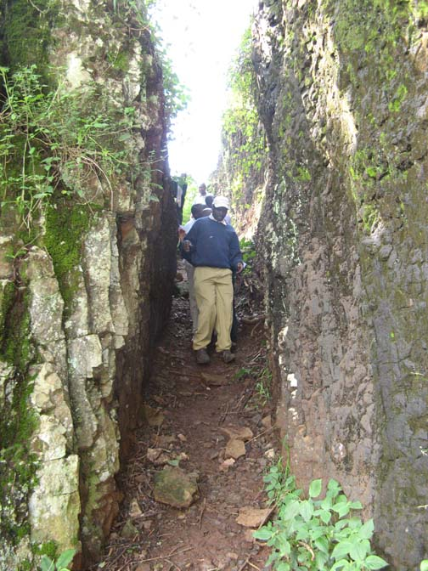

This sites can be nominated under criteria 8 which states; be outstanding example representing major stages of earth’s history, including the record of life, significant on-going geological processes in the development of landforms, or significant geomorphic or physiographic features.

BLESSED IRENE STEFANI (NYAATHA) SHRINE

Sister Irene Stefani was born at Anfo, Brescia (Italy) on 22nd August 1891 in a family of twelve (12) children. Five of her siblings latter died, followed by the death of her parents hence leaving her with the responsibility of parenting her siblings. At the age of 20 years, she joined the Consolata Sisters, a congregation founded by Blessed Joseph Allamano (Mina & Gatti, nd).

On 2nd April, 2011 Pope Benedict XVI authorized the issuance of a decree on her “Heroic Virtues” and Sister Irene was proclaimed Venerable, hence taking up the status ‘Servant of God’. One of the heroic virtues when Sister Irene learnt that one of her students, Mr. Julius Ngari was sick and decided to visit him, ignoring the fact that he was suffering from plague. From this encounter, Sister Irene Stefani also contracted the dreaded plague that eventually caused her death. It was out of these acts of Mercy that she was nicked-named, Nyaatha (that can be translated to Merciful mother). She also worked with a Medical Colonel to nurse those injured in military hospitals in Kenya and Tanzania (NB: Sister Irene had not trained as a nurse). She engaged in outreach catechism and nursing, targeting the aged and sick in the villages.
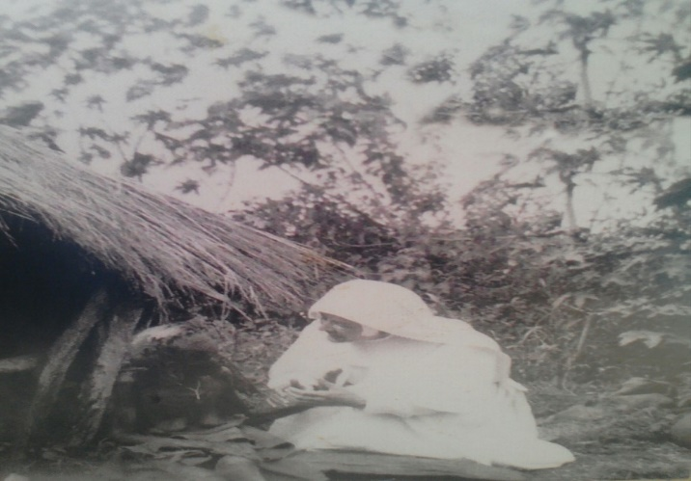
Sister Irene Stefani attending to a patient in the village (source: Gĩkondi shrine)

The shrine is located approximately 32 kilometers south-west of Nyeri town in the following administrative jurisdiction.
Sub Location: Kiîrungi
Location: Mũkũrwe-ini East
Sub County: Mũkũrwe-ini
County: Nyeri
Coordinates: 00.57561⁰ S, 037.03200⁰ E, Elevation 1758 M
Size: Approximately 20 x 50ft (area occupied by the shrine)

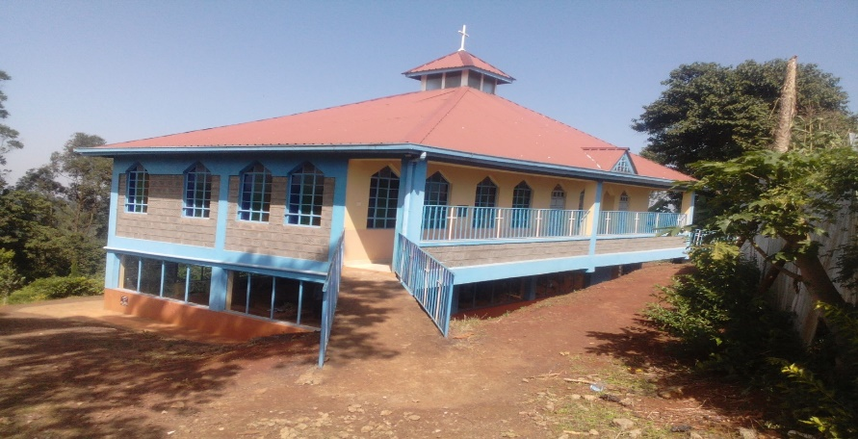

The shrine-with a similar design to the original wooden house built in 2016
Administrative Location

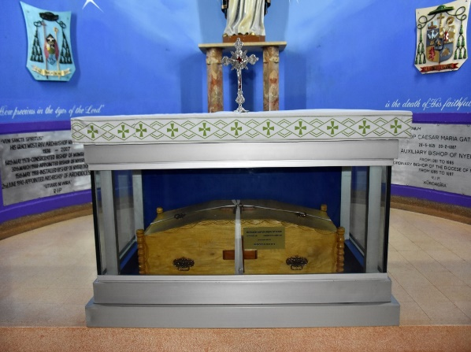
Vault containing the relics of Blessed Irene Stefani inside Nyeri Cathedral

Her relics/remains are secured at special altar on the left side of this Cathedral, where faithful are allowed to offer their intercessory prayers.
This site can also be nominated under criteria 6 which states; be directly or tangibly associated with events or living traditions, ideas, or beliefs, with artistic and literary works of outstanding universal significance.

FLAG SITE

It is the site where the Kenyan flag was raised for the first time. It was green, black and red without the white color and the shield. It is an open space with grass and small bushes. It is used for grazing and also a volley ball pitch. The grounds are also famous as the site where Mau Mau laid down arms in 1964.

Administrative Location

Sub-location: Rũring’u
Location: Rũring’u
Sub-County: Nyeri Central
County: Nyeri
GPS Coordinates: S00°26’25.6” and E036°57’46.2”
Elevation: 1788 meters
Acreage: Approximately 1.5 acres
Distance: Approximately 3 Kilometers from Nyeri Town.

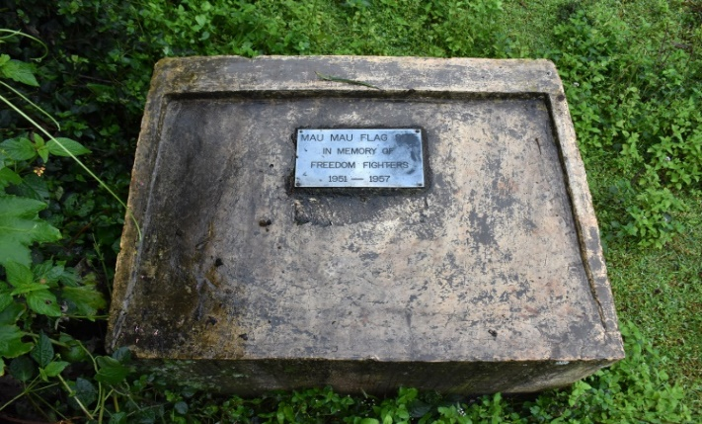
Mau Mau Flag Site
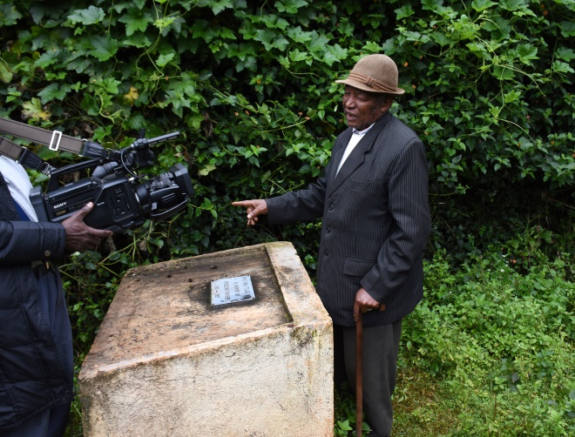
Captain Nderitu at the Mau Mau flag site

This site can be nominated as a world heritage site under criteria 2 which states; exhibit an important interchange of human values, over a span of time or within a cultural area of the world, on developments in architecture or technology, monumental arts, town planning or landscape design.

CHINGA DAM
Chinga dam is one the heritage sites in Nyeri County that considerably manifests the sufferings that Mau Mau detainees/prisoners underwent. Just like at Gĩthunguri Stadium in Kĩambu, Chinga was dug using bare hands without machinery, resulting to loss of life due to immense hardships encountered.

Administrative Location
Sub-location: Gĩchichi
Location: Chinga
Sub-County: Othaya
County: Nyeri
GPS Coordinates: S00°35’0.04” and E036°55’13.4”
Elevation: 1894meters
Distance: Approximately 26 Kilometers from Nyeri Town on Othaya-Kĩria-ini Road.
The purpose of the dam was to produce hydro-electric power for the area and for irrigation at Kakuzi. The Europeans were to grow coffee and French beans. The dam is fed by seven streams; namely Chinga (main), Kanyonyo, Mitai,Gatahiro, Kanyiriri, Kahuro and Kanungu. It only has one outlet, Gikira River. In 1982, a water intake was constructed to supply piped water to the people in Mũkũrwe-ini for domestic use. The community does fishing on a small scale. The water is also used for washing and bathing. The dam in yester years was referred to as ‘the killer dam’. It is approximately 152 acres in size, the longest stretch being 2.79 kilometers and 873 meters wide. The dam has tilapia, mudfish and eel. Eel is scarce and has not been caught in the last four years. Fish caught from the dam is consumed domestically or sold.
This site can be nominated as a world heritage site under criteria 1 which states represent a masterpiece of human creative genius.
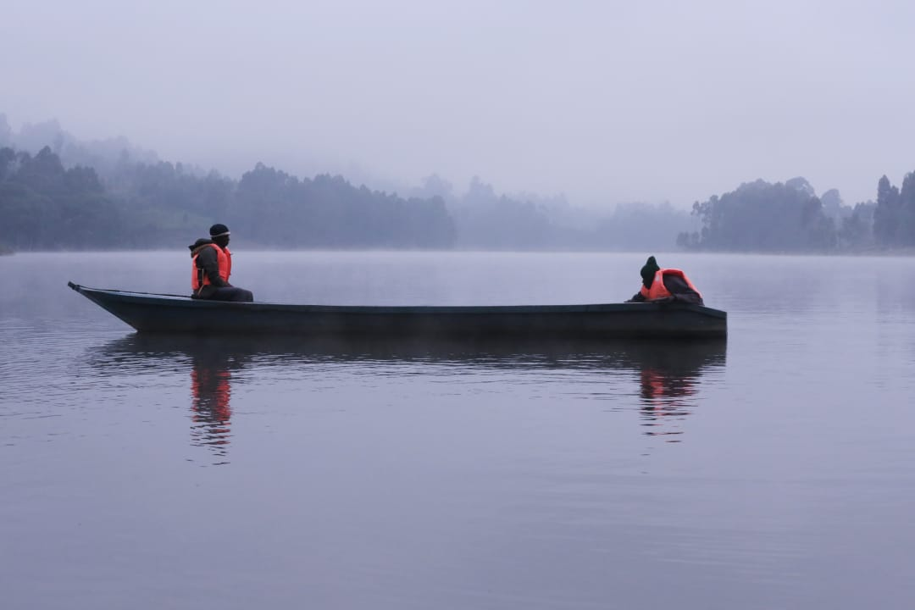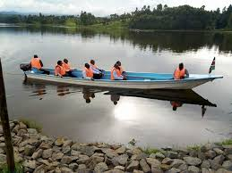
Chinga Dam

MAU MAU GRAVES
This Mau Mau grave site is one of the many such mass graves that dot various villages in Nyeri County; some are well known and documented while others are not. This Mau Mau mass grave at Kĩirungi is located at the Junction of Mũkũrwe-ini - Mũthuthi-ini road.
Among the Mau Mau and the senior citizens, this mass grave site is well known because it is associated with General Gathũmbi. The general was heading a Mau Mau contingent and fighting from this area. It was in 1954, when there was a huge screening exercise when his team was surrounded by British military and shot while atop a tree (with his body guard). The fighting that took his life and that of some of his fighters took place near the Rwarai River, according to our informant Mr. Tarasicio Waweru Kĩhia.

2.10.2 Administrative location
Sub-location: Kîirungi
Location: Gĩkondi
Division: Mũthuthi-ini
Sub-county: Mũkũrwe-ini
County: Nyeri
Coordinates: 00.57651⁰ S and 037.04083⁰ E
Ownership: This plot is privately owned. Plot No. 274/ Mũkũrwe-ini
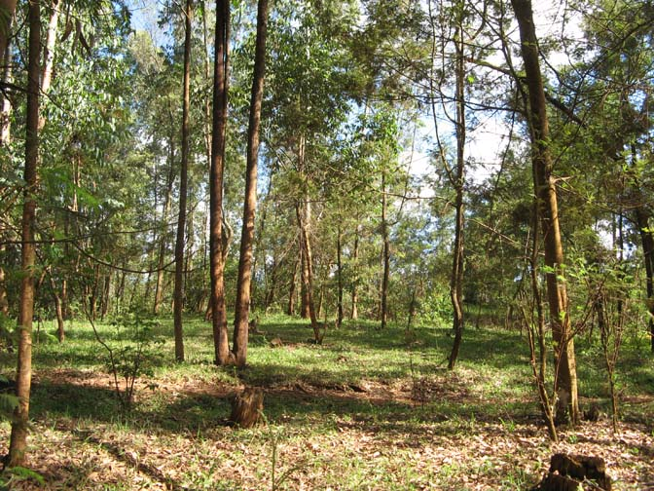
Mau Mau Mass grave at Kĩirungi – Gĩkondi

Freedom Fighters Buried at Site
The following listed heroes and heroines were mentioned as some of the freedom fighters resting on a section of the above-mentioned plot.
- General Gathũmbi - Kariuki Macharia (Kînyuga)
- Gîchuki wa Ndii - Gîitwa wa Wakahia
- Ngumo wa Mugecha - Wajama Githua
- Kararu - Ng’ondu
- Wathaka Kîriungi - Kanyoni wa Kîgumo
- Karoge Mariitinu - Maina Ambrose Kîhatha
- Kîrigo wa Njogu - Monica wa Kîgamba
- Sergent Nyambura - Mũrinji Ituu
- Nthiga Kaniaru
This site can be nominated as a world heritage site under criteria 3 which states bear a unique or at least exceptional testimony to a cultural tradition or a civilization which is living or which has disappeared.

ABERDARE NATIONAL PARK
The Aberdare National Park is 750 kilometers square mountain range west of Mount Kenya. There are two famous hotel lodges (The Ark and Treetops) inside the park where most visitors stay, mostly overnight, watching wildlife around the saltlick ponds close by. The wildlife frequenting the saltlicks are mainly Elephants and Buffalos, waterbucks, other Antelopes, giant forest Hog, Hyenas and rarely Leopards. As one ascends towards the peak above the forest is a belt of bamboo, a favorite habitat for the Bongo, a rare and elusive forest Antelope. \At about 10,000ft the bamboo gives way to moorland, home to Eland, spotted and serval cats. Other notable features are the giant alpine varieties of lobelia, groundsel and heather.
Other characteristic features are streams and rivers that cascade down through spectacular waterfalls in the moorland. Among the most remarkable waterfalls include the Chania, Magura, Zaina and Karuru falls. Karuru falls is the tallest fall in Kenya at 273 m below the viewing point. Within the moorlands, one can get out of their vehicles and walk to the base or viewing points in case of Chania or Karuru falls respectively.
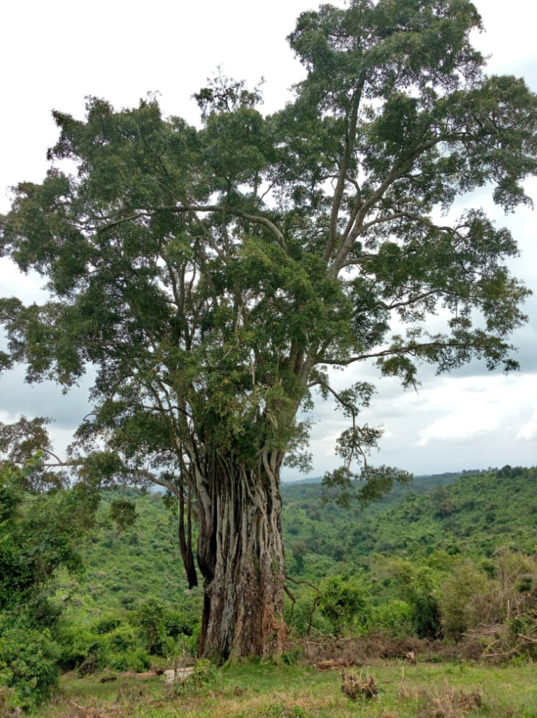
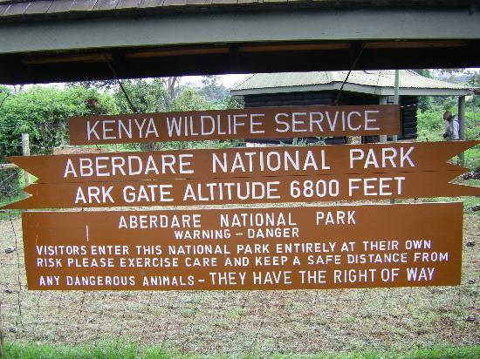
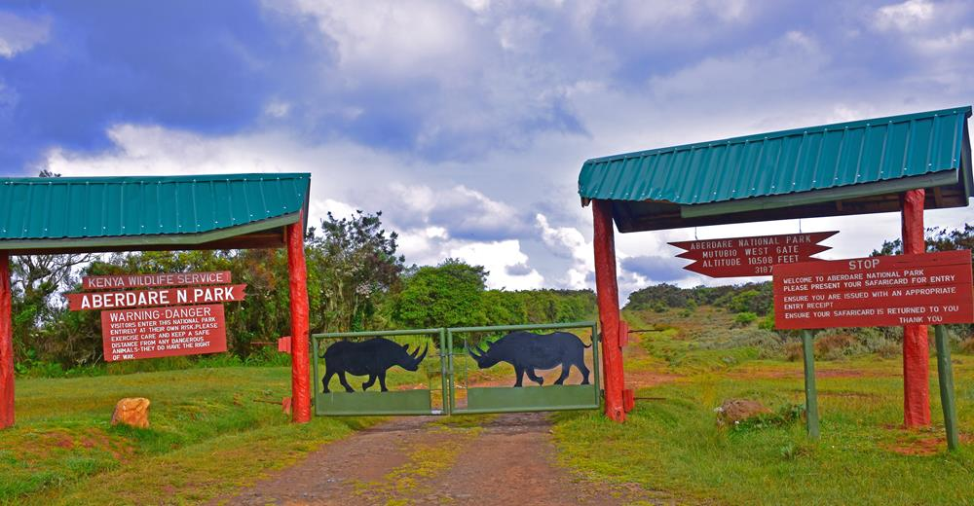
Aberdare National Park
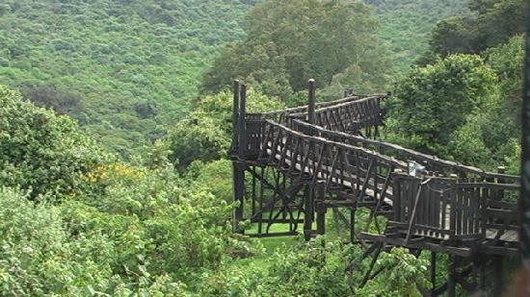
A nature walk trail
The park is an important water catchment area providing water to the Tana and Athi rivers and part of central rift and northern drainage basins. Visitors can enjoy various activities such as
- game viewing and tracking
- nature walks,
- fishing,
- camping
- bird watching
- trout fishing in the cold mountain streams
- mountain hiking
- photography
- honeymooning
- cave explorations
- picnics

This site can be nominated as a world heritage site under criteria 7 which states contain superlative natural phenomena or areas of exceptional natural beauty and aesthetic importance.

WANGARI MAATHAI
Wangari Muta Maathai was born in 1940, Tetu sub county, Nyeri County. She obtained first degree in Biological Sciences from Mount St. Scholastica College in Atchison, Kansas (1964), a Master of Science degree from the University of Pittsburgh (1966), and pursued doctoral studies in Germany and the University of Nairobi, before obtaining a Ph.D. (1971) from the University of Nairobi, where she also taught veterinary anatomy. She is the first woman in East and Central Africa to earn a doctorate degree.

Professor Wangari Maathai

Professor Maathai was active in the National Council of Women of Kenya (1976–1987) and was its chairman (1981–1987). In 1976, while she was serving in the National Council of Women, Professor Maathai introduced the idea of community-based tree planting. She continued to develop this idea into a broad-based grassroots organisation, the Green Belt Movement (GBM), whose main focus is poverty reduction and environmental conservation through tree planting.
Professor Maathai was internationally acknowledged for her struggle for democracy, human rights, and environmental conservation, and served on the board of many organisations. She addressed the UN on a number of occasions and spoke on behalf of women at special sessions of the General Assembly during the five-year review of the Earth Summit. She served on the Commission for Global Governance and the Commission on the Future.
In recognition of her deep commitment to the environment, the United Nations (UN) Secretary-General named Professor Maathai a UN Messenger of Peace in December 2009, with a focus on the environment and climate change.

This site can be nominated as a world heritage site under criteria 2 which states; exhibit an important interchange of human values, over a span of time or within a cultural area of the world, on developments in architecture or technology, monumental arts, town planning or landscape design

REFERENCES

- Carter, I. (2018): How Italy Was Defeated In East Africa In 1941. Imperial war museums. [Online] 18th June 2018. Available from https://www.iwm.org.uk/history/how-italy-was-defeated-in-east-africa-in-1941. [Accessed 8th Aug 2018]

- Gichere, N. (2009): Report on The tour of Sites and Monuments in Central Region-part one. Unpublished fieldwork report.

- History.com Editors (2009): Boy Scout movement begins [Online]. Available from https://www.history.com/this-day-in-history/boy-scouts-movement-begins[Accessed on 11/09/18].

- Kanogo T. (1987). Squatters and Roots of Mau Mau. Nairobi, James Curry.

- Mina, G.P. & Gatti, F. (nd): Blessed Irene “Nyaatha”, an abstract of” GLJ SCARPONI DELLA GLORIA. Makuyu. Don Bosco printing press.

- Murumba, S. (2013): The little known Italian heritage in Nyeri town. Daily Nation. [Online] 21st July 2013. Available from https://www.nation.co.ke/lifestyle/dn2/Italian-heritage-in-Nyeri-town/957860-1922228-2n4dp9z/index.html. [Accessed 8th August 2018]

